Employee Sentiment Analysis Report

1. Methodology Overview
We analyzed internal communication data to understand employee sentiment trends and potential engagement risks. The workflow consisted of the following key stages:
- Sentiment Labeling: Used VADER (Valence Aware Dictionary and sEntiment Reasoner) to classify each message as Positive (+1), Neutral (0), or Negative (-1).
- Monthly Aggregation: Calculated cumulative sentiment scores per employee per month.
- Ranking: Identified top 3 most positive and negative employees each month.
- Flight Risk Detection: Flagged employees who sent 4 or more negative messages in any rolling 30-day window.
- Predictive Modeling: Built a linear regression model to explore if future sentiment scores could be predicted from time and frequency-based features.

2. Exploratory Data Analysis (EDA)

Data Overview
- Total Records: 2,191
- Columns: from, date, subject, body, sentiment_vader
- Missing Values: None in critical columns

Sentiment Distribution
- Positive: 1,525 messages
- Neutral: 508 messages
- Negative: 158 messages
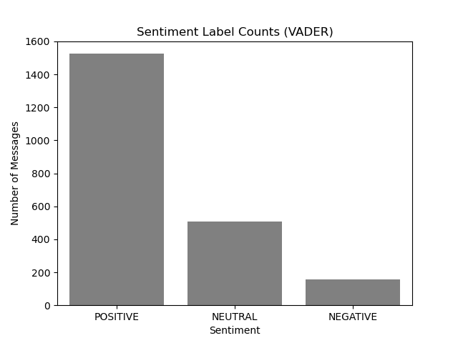

Trends Over Time
- Positive sentiment was dominant, though there were spikes in Negative sentiment in specific months.
- Sentiment trends were plotted monthly and annually using line charts.
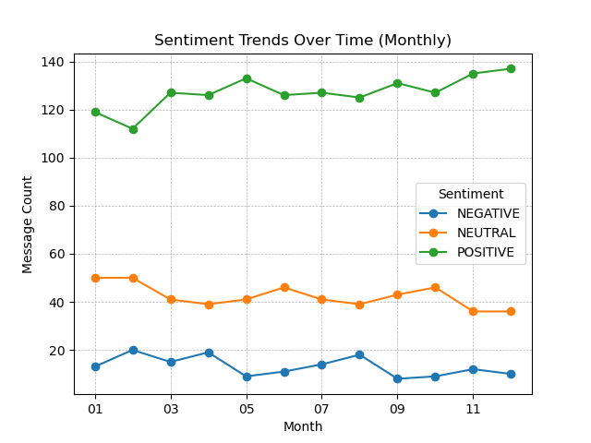
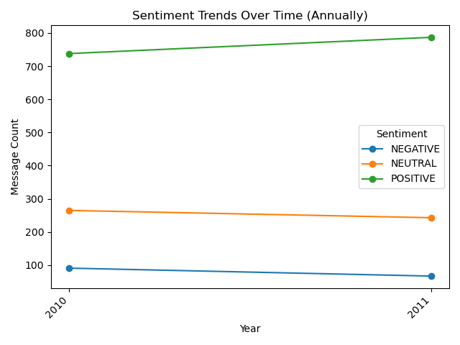

Message Length by Sentiment
- Neutral messages tended to be longer.
- Negative messages showed greater variation in length.
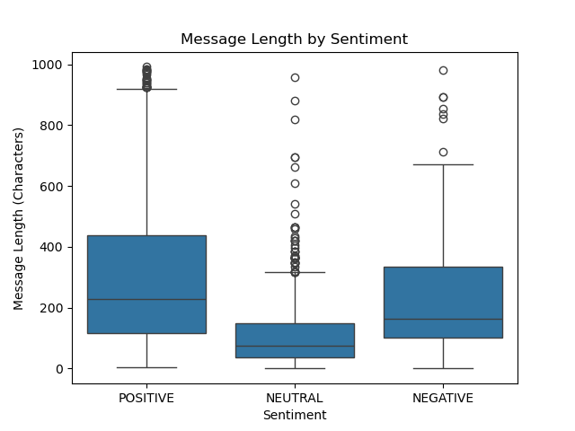

Top Message Senders
- The most active communicators were identified, possibly indicating leadership roles or signs of overload.
- Top 10 senders: 'lydia.delgado@enron.com', 'john.arnold@enron.com', 'sally.beck@enron.com', 'patti.thompson@enron.com', 'bobette.riner@ipgdirect.com', 'johnny.palmer@enron.com', 'don.baughman@enron.com', 'eric.bass@enron.com', 'kayne.coulter@enron.com', 'rhonda.denton@enron.com'
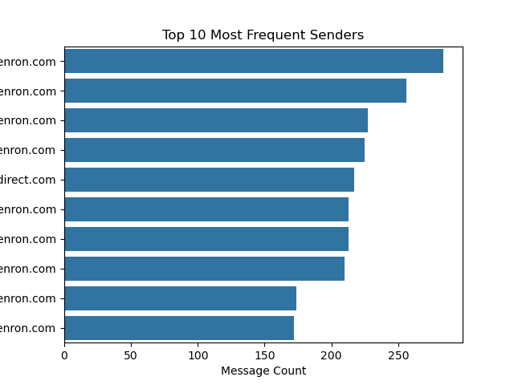

3. Employee Scoring & Ranking
Each employee was assigned a monthly sentiment score:
- Positive message: +1
- Neutral message: 0
- Negative message: -1
The top 3 Positive and Negative employees for each month were identified by:
- Sorting by sentiment score (descending for positive, ascending for negative)
- Breaking ties alphabetically
A final table includes these ranked employees with their scores and months.
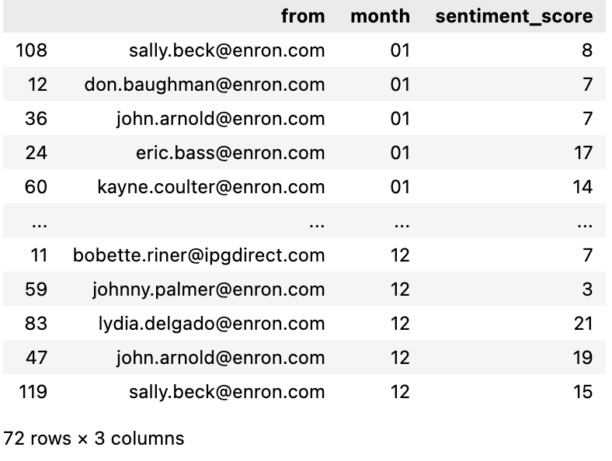

4. Flight Risk Detection

Criteria:
- An employee is flagged as a flight risk if they send 4 or more Negative messages within any 30-day period, regardless of sentiment score.

Implementation:
- Used a rolling window approach grouped by sender.
- Compared timestamps of all negative messages per employee.

Outcome:
- Employees flagged:
  - johnny.palmer@enron.com
  - john.arnold@enron.com
  - bobette.riner@ipgdirect.com
  - kayne.coulter@enron.com
  - sally.beck@enron.com
  - don.baughman@enron.com
These employees exhibited sustained negative sentiment and should be considered at risk of disengagement.

5. Predictive Modeling

Goal:
To determine whether time- or behavior-based features can predict monthly sentiment scores.

Features Used:
- year
- month
- message_length

Model:
- Linear Regression
- Train/Test Split: 70% train, 30% test

Results:
- Mean Squared Error: 0.3739
- R² Score: 0.063

Interpretation:
- The model has low predictive power (R² ≈ 6.3%).
- The most influential feature was year, but its effect was minimal.
- This suggests that linear patterns alone do not explain sentiment changes effectively.

Recommendation:
- Engineer more meaningful features
- Use larger dataset
- Try non-linear models.

6. Conclusion & Recommendations
- Most employee communications were positive, though a few exhibited repeated negativity.
- Monthly sentiment tracking and flight risk analysis are viable tools for early engagement detection.
- The linear regression model was limited in predictive power; more complex models and richer features are recommended.

